Whitney architecture –

High Level PD Design

High-level Design

Rev. 1.0

Apr. 7, 2017

Revision history

| Revision | Date | Description |
| --- | --- | --- |
| 1.0 | Apr. 7th, 2017 | Initial release |
|  |  |  |
|  |  |  |
|  |  |  |

Contents

1 Introduction 6

1.1 Scope 6

1.2 Terminology 6

1.3 Overview 6

2 PD architecture 7

2.1 Functional Block Diagram 7

2.2 Interfaces Signals 7

2.2.1 Signals between Protocol and Policy Engine 7

2.2.2 Signals between Policy Engine and Device Policy Manger 8

2.3 Feature Description 9

2.3.1 Physical Layer 9

2.3.2 Protocol Layer 11

2.3.3 Policy Engine 12

Figures

Figure 1 PD Top level block diagram 7

Tables

Table 1 Block function brief description 8

# **Introduction**

## Scope

## Terminology

|  |  |
| --- | --- |
| **Item** | **Descriptions** |
|  |  |
|  |  |

## Overview

* Supports PD2.0 and PD3.0 specifications
* Supports OTP (One Time Programing)
* Bi-Phase Marked Encoding/Decoding (BMC)
* Physical Layer and Policy Engine
* Used as Source and not support role swap
* Support Power Negotiation
* Support Soft Reset
* Support Hard Reset
* Support BIST

# PD architecture

## Functional Block Diagram

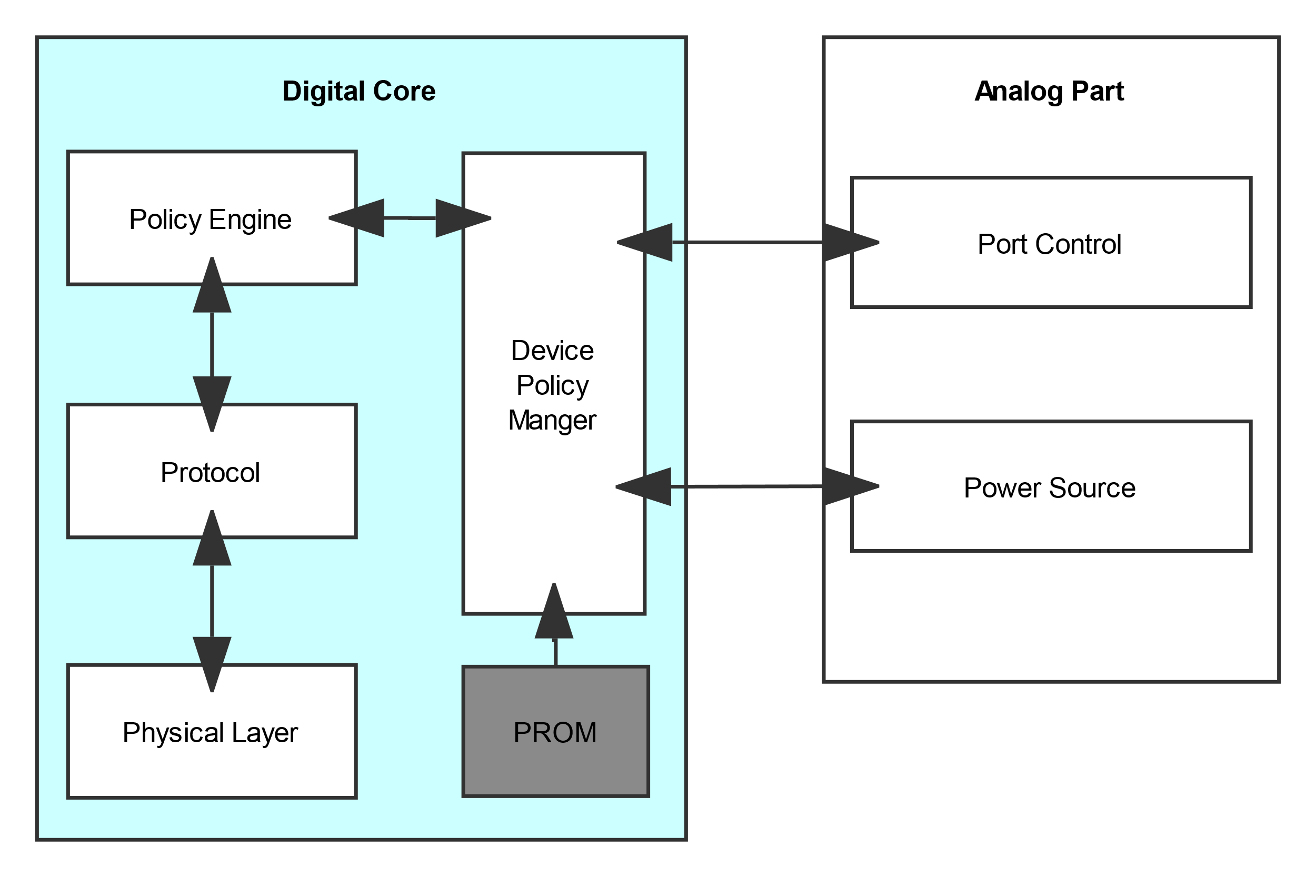

* Figure PD Top level block diagram

A **Device Policy Manager** that exists in all devices and manages USB Power Delivery resources within the device across one or more ports based on the Device’s Local Policy.

A **Policy Engine** that exists in each USB Power Delivery Port implements the Local Policy for that Port.

A **Protocol Layer** that enables Messages to be exchanged between a Source Port and a Sink Port.

A **Physical Layer** that handles transmission and reception of bits on the wire and handles data transmission.

## Interfaces Signals

### Signals between Protocol and Policy Engine

|  |  |
| --- | --- |
| Signals | Description |
| PE2PL_AMS_begin |  |
| PE2PL_AMS_end |  |
| PE2PL_hard_reset |  |
| PE2PL_hard_reset_finish |  |
| PE2PL_ProtocolLayer_reset |  |
| PE2PL_send_Accept |  |
| PE2PL_send_Get_SinkCap |  |
| PE2PL_send_PS_RDY |  |
| PE2PL_send_Reject |  |
| PE2PL_send_Soft_Reset |  |
| PE2PL_send_SrcCap |  |
| PL2PE_Accept_received |  |
| PL2PE_Get_Country_Codes_received |  |
| PL2PE_Get_Country_Info_received |  |
| PL2PE_Get_Manufacturer_Info_received |  |
| PL2PE_Get_PPS_Status_received |  |
| PL2PE_Get_SrcCap_Ex_received |  |
| PL2PE_Get_SrcCap_received |  |
| PL2PE_Get_Status_received |  |
| PL2PE_GoodCRC_received |  |
| PL2PE_Not_Supported_received |  |
| PL2PE_Request_received |  |
| PL2PE_Sink_Alert_received |  |
| PL2PE_SinkCap_received |  |
| PL2PE_send_Accept_done |  |
| PL2PE_send_Reject_done |  |
| PL2PE_without_GoodCRC |  |
| PL2PE_Protocol_Error |  |
| PL2PE_ProtocolLayer_reset_done |  |
| PL2PE_HardReset_received |  |

### Signals between Policy Engine and Device Policy Manger

|  |  |
| --- | --- |
| Signals | Description |
| PE2DPM_get_SrcCap |  |
| PE2DPM_Request_evaluate |  |
| PE2DPM_trans_supply |  |
| PE2DPM_reset |  |
| PE2DPM_turn_on_vconn |  |
| DPM2PE_attached |  |
| DPM2PE_request_identity_discovery |  |
| DPM2PE_evaluate_finish |  |
| DPM2PE_Request_met |  |
| DPM2PE_Request_met_later |  |
| DPM2PE_trans_finish |  |
| DPM2PE_default_supply |  |

### Signals Between Digital Core and Analog Part

|  |  |
| --- | --- |
| Signals | Description |
| TBD |  |
| TBD |  |

## Feature Description

### Physical Layer



The physical layer block diagram includes two sections, the data path and the control path. The data path also has two sections, the Tx data path and the Rx data path. The Tx data path is from the packet to bit stream, includes the Tx Packet Editor, 4B5B Encoder and BMC Encoder; the Rx data path is opposing flow, includes the RX Date IF, 4B5B Decoder, K-code Detect and BMC Decoder. Also two path share the same CRC Calculate for error detection. The control path includes the Tx/Rx control state machines and Collision Control, make certain data path work correctly.

#### Bi-Phase Marked Coding

The encoding scheme used for the baseband PD signal is a version of Manchester coding called Bi-phase Mark Coding (BMC). In this code, a transition occurs at the start of every bit time and a second transition occurs in the middle of the bit cell when a 1 is transmitted. This coding scheme is nearly DC balanced with limited disparity (limited to 1/2 bit over an arbitrary packet, so a very low DC level).

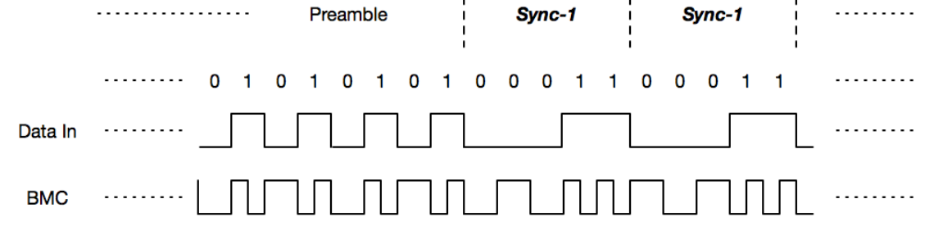

#### K-code Detect

|  |  |  |  |  |  |
| --- | --- | --- | --- | --- | --- |
| K-code number | K-code in code table | | | | |
| **SOP** | **SOP’** | **SOP’’** | **Hard Reset** | **Cable Reset** |
| 1 | Sync-1 | Sync-1 | Sync-1 | Rst-1 | Rst-1 |
| 2 | Sync-1 | Sync-1 | Sync-3 | Rst-1 | Sync-1 |
| 3 | Sync-1 | Sync-3 | Sync-1 | Rst-1 | Rst-1 |
| 4 | Sync-2 | Sync-3 | Sync-3 | Rst-2 | Sync-3 |

#### 4B5B Code

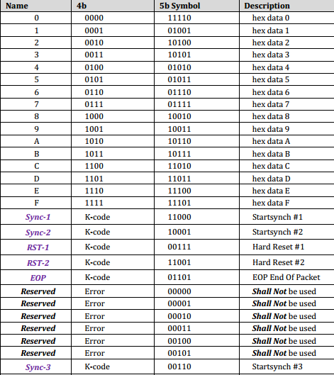

#### CRC Calculate

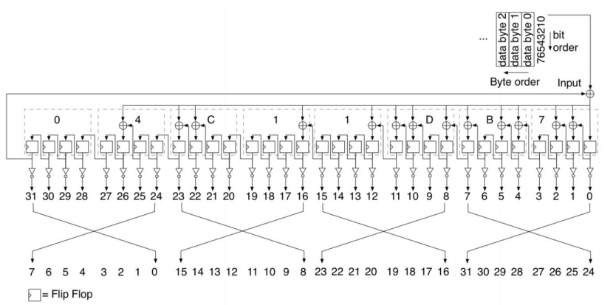

### Protocol Layer



The protocol layer block diagram also includes two sections, the data path and the control path. The data path also has two sections, the Tx data path and the Rx data path. The Tx data path includes the Tx Data Buffer, Tx Packet Editor and Tx Data IF; the Rx data path is opposing flow, includes the RX Date IF, Rx Packet Parser and Rx Data Buffer. The control path includes the Tx/Rx/HardReset control state machines and the corresponding timer/counter control, make certain data path work correctly.



1. The PHY Layer reset is complete
2. A Message request is received from the Policy Engine which is not a Soft_Reset Message
3. The Message has been sent to the PHY Layer
4. A GoodCRC Message response is received from the PHY Layer
5. The MessageIDCounter and the MessageID of the received GoodCRC Message match
6. The Policy Engine has been informed that the Message has been sent
7. A notification is received from the Policy Engine that the end of an AMS has been reached
8. Rp has been set
9. A notification is received from the Policy Engine that an AMS will be starting
10. A Message request is received from the Policy Engine
11. The SinkTxTimer times out and Soft_Reset Message
12. The SinkTxTimer times out and No Soft_Reset Message
13. A Message request is received from the Policy Engine which is a Soft_Reset Message
14. The CRCReceiveTimer times out or a Message has been Discarded
15. The MessageIDCounter and the MessageID of the received Message do not match
16. RetryCounter ≤ nRetryCount and not a Cable Plug and A “small” Extended Message
17. Protocol Layer Message reception receives an incoming Message
18. Discarding is complete
19. At startup or a Soft Reset request being received or On exit from a Hard Reset
20. The layer reset actions in this state have been completed
21. RetryCounter > nRetryCount or Cable Plug, not retry or A “big” Extended Message
22. The Policy Engine has been informed of the transmission error



1. A Message is passed up from the PHY Layer, not Soft_Reset Message
2. The GoodCRC Message has been passed to the PHY Layer
3. The MessageID of the received Message does not equal the stored MessageID
4. The Message has been passed up to the Policy Engine
5. The MessageID of the received Message equals the stored MessageID value
6. A Message has been Discarded due to CC being busy but CC is now idle
7. The Soft Reset actions in this state have been completed
8. A Soft_Reset Message is received from the PHY Layer
9. Start up or a Soft Reset request from the Policy Engine or On exit from a Hard Reset



1. The Protocol Layer’s reset is complete and from PE
2. The Physical Layer Cable/Hard Reset Signaling request has been sent
3. A Cable/Hard Reset complete or The HardResetCompleteTimer times out
4. The Indication to the Policy Engine has been sent
5. A Cable/Hard Reset complete indication is received from the Policy Engine
6. The Protocol Layer’s reset is complete and from PHY
7. The Indication to the Policy Engine has been sent
8. A Hard/Cable Reset Request

#### Control Message



|  |  |  |  |
| --- | --- | --- | --- |
| **Bits 4…0** | **Message Type** | **Sent by** | **Valid Start of Packet** |
| 0 0001 | ***GoodCRC*** | Source, Sink or Cable Plug | SOP* |
| 0 0011 | ***Accept*** | Source, Sink or Cable Plug | SOP* |
| 0 0100 | ***Reject*** | Source or Sink | SOP only |
| 0 0110 | ***PS_RDY*** | Source or Sink | SOP only |
| 0 0111 | ***Get_Source_Cap*** | Sink or DRP | SOP only |
| 0 1101 | ***Soft_Reset*** | Source or Sink | SOP* |
| 1 0000 | ***Not_Supported*** | Source, Sink or Cable Plug | SOP* |
| 1 0001 | ***Get_Source_Cap_Extended*** | Sink or DRP | SOP only |
| 1 0010 | ***Get_Status*** | Source or Sink | SOP only |

#### Data Message



|  |  |  |  |
| --- | --- | --- | --- |
| **Bits 4…0** | **Type** | **Sent by** | **Valid Start of Packet** |
| 0 0001 | ***Source_Capabilities*** | Source or Dual-Role Power | SOP only |
| 0 0010 | ***Request*** | Sink only | SOP only |
| 0 0011 | ***BIST*** | Tester, Source or Sink | SOP* |
| 0 0110 | ***Alert*** | Source or Sink | SOP only |
| 0 0111 | ***Get_Country_Info*** | Source or Sink | SOP only |
| 0 1111 | ***Vendor_Defined*** | Source, Sink or Cable Plug | SOP* |

#### Extended Message



|  |  |  |  |
| --- | --- | --- | --- |
| **Bits 4…0** | **Type** | **Sent by** | **Valid Start of Packet** |
| 0 0001 | ***Source_Capabilities_Extended*** | Source or Dual- Role Power | SOP only |
| 0 0010 | ***Status*** | Source or Sink | SOP only |
| 0 0110 | ***Get_Manufacturer_Info*** | Source or Sink | SOP* |
| 0 0111 | ***Manufacturer_Info*** | Source, Sink or Cable Plug | SOP* |
| 0 1100 | ***PPS_Status*** | Source | SOP only |
| 0 1101 | ***Country_Info*** | Source, Sink or Cable Plug | SOP* |
| 0 1110 | ***Country_Codes*** | Source, Sink or Cable Plug | SOP* |

### Policy Engine

#### Main FSM

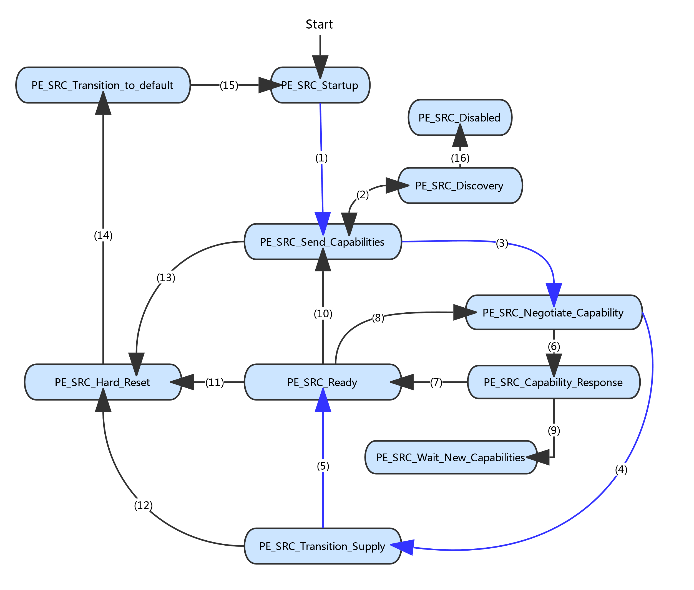

1. Plug is Attached & Protocol Layer reset has completed
2. Without GoodCRC / SourceCapabilityTimer timeout & (CapsCounter <= nCapsCount)
3. A Request Message is received from the Sink
4. The Request can be met
5. Power supply is ready
6. Request can’t be met
7. Explicit Contract & (Reject message sent &Contract still valid)
8. Request message received
9. No Explicit Contract & Reject message sent
10. Get_Source_Cap Message received
11. SourcePPSCommTimer timeout
12. Protocol Error occurs
13. The SenderResponseTimer times out
14. The PSHardResetTimer times out
15. Power supply has reached the default level
16. SourceCapabilityTimer timeout & (CapsCounter > nCapsCount)

#### Reset and Protocol Error

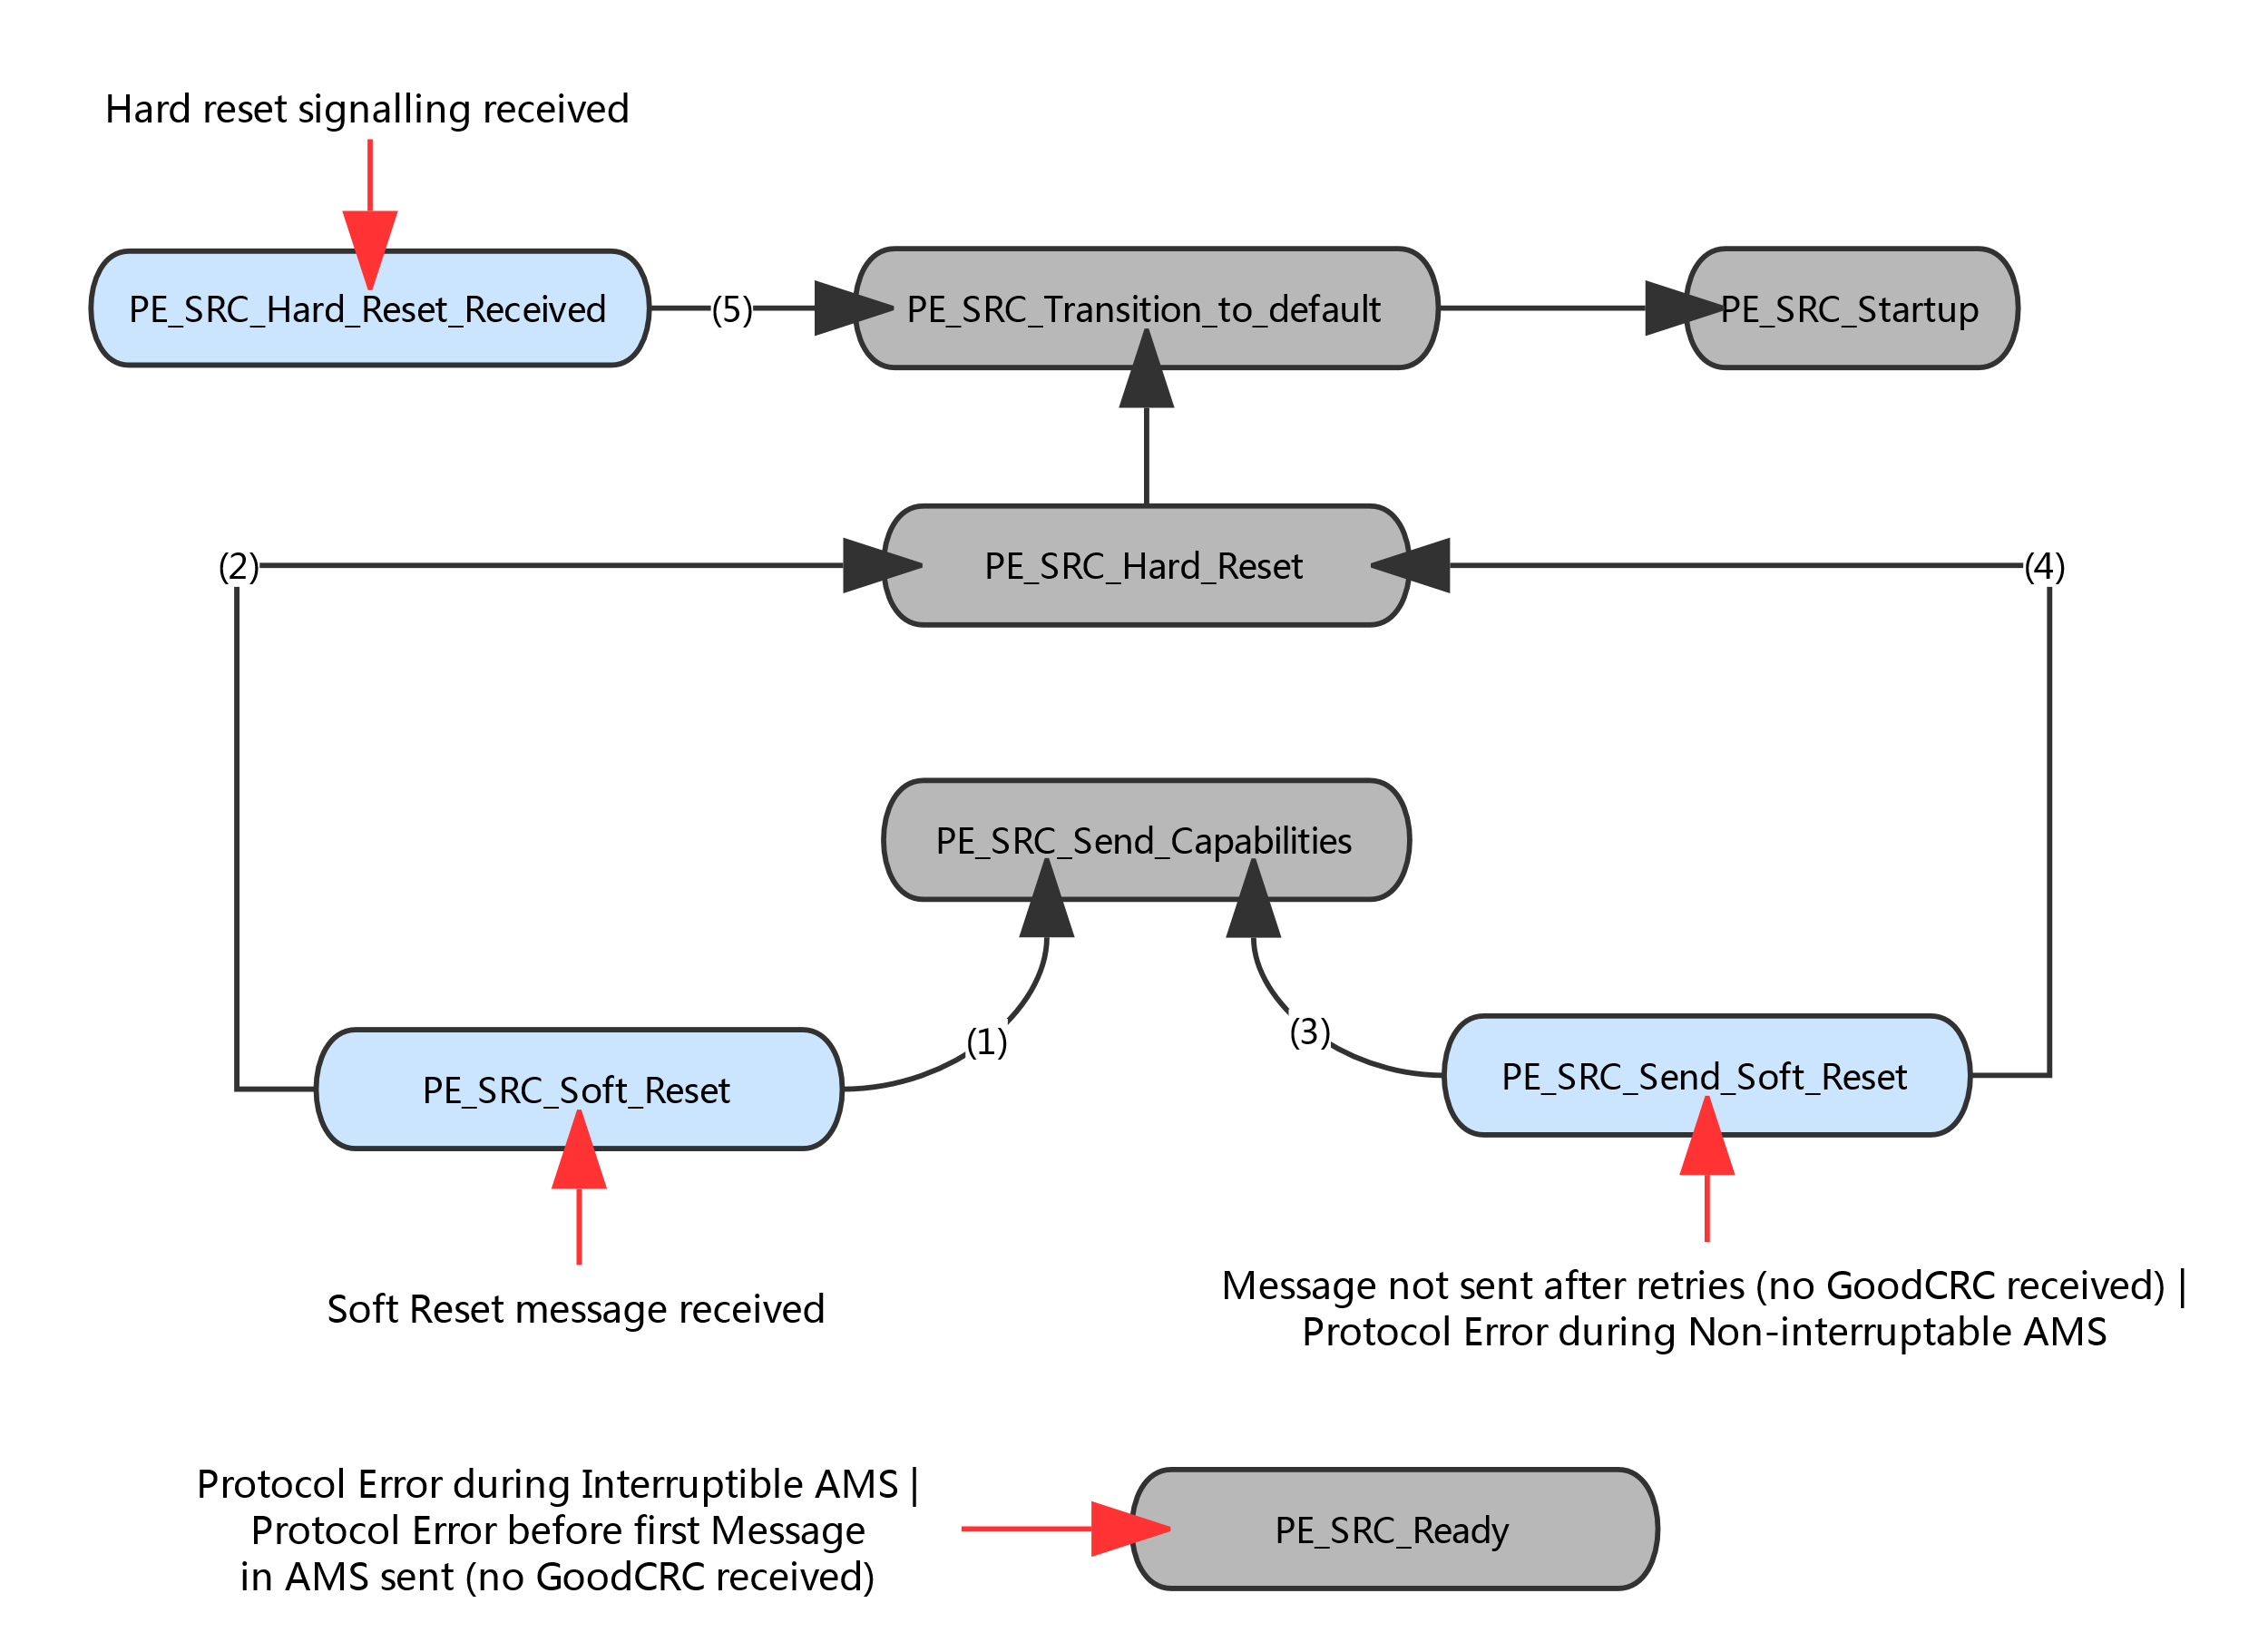

1. Accept message sent
2. Transmission Error indication from Protocol Layer
3. Accept message received
4. SenderResponseTimer Timeout | Transmission Error indication from Protocol Layer